[System] Libraries loaded successfully. Computing device: cuda

==========================================================================================
🧠 Initialize PBT-V Architecture (DINOv2-Small Backbone)
==========================================================================================
preprocessor_config.json: 100%
436/436 [00:00<00:00, 56.3kB/s]
The image processor of type `BitImageProcessor` is now loaded as a fast processor by default, even if the model checkpoint was saved with a slow processor. This is a breaking change and may produce slightly different outputs. To continue using the slow processor, instantiate this class with `use_fast=False`.
config.json: 100%
547/547 [00:00<00:00, 64.0kB/s]
model.safetensors: 100%
88.2M/88.2M [00:02<00:00, 92.1MB/s]
Loading weights: 100%
223/223 [00:00<00:00, 999.50it/s, Materializing param=layernorm.weight]
[System] Model & PBT-V Adapter ready.

==========================================================================================
🎥 Generating Synthetic Video Sequences for PBT-V Testing
==========================================================================================
[Dataset] Safe Video Tensor shape: torch.Size([10, 3, 224, 224])
[Dataset] Unsafe Video Tensor shape: torch.Size([10, 3, 224, 224])
[System] Video Sequences generated and processed successfully.

==========================================================================================
⚙️ Pre-computing Hidden States from DINOv2
==========================================================================================
[Process] Extracting features for Safe Video Sequence...
[Process] Extracting features for Unsafe Video Sequence...
[Result] Safe features shape: torch.Size([10, 12, 384])
[Result] Unsafe features shape: torch.Size([10, 12, 384])

==========================================================================================
🚀 CELL 4: Training PBT-V Adapter (Temporal Reflex Learning)
==========================================================================================
[Process] Starting Backpropagation Through Time (BPTT) training loop...
Epoch 10/40 | Loss: 0.2653 | γ_pain: 0.0427
Epoch 20/40 | Loss: 0.0090 | γ_pain: 0.0394
Epoch 30/40 | Loss: 0.0034 | γ_pain: 0.0390
Epoch 40/40 | Loss: 0.0027 | γ_pain: 0.0390
[System] PBT-V Training completed successfully!
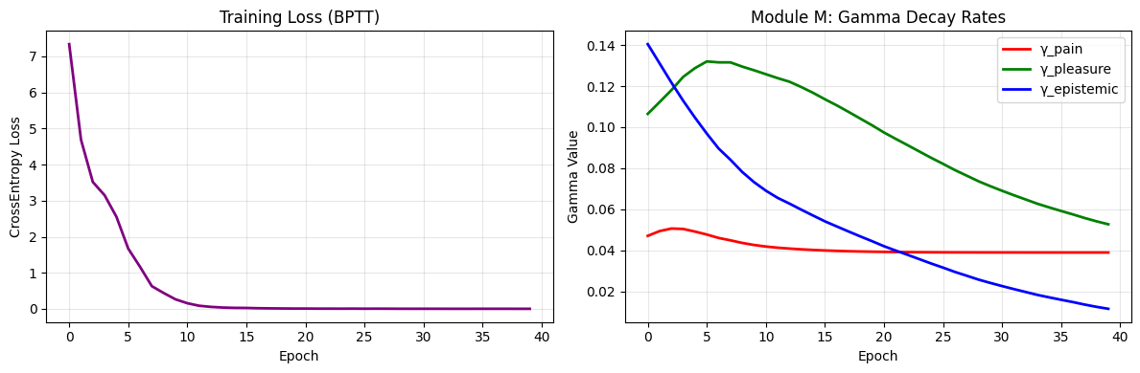

==========================================================================================
⏱️ CELL 5: Temporal Reflex Scanner (Robot EEG Analysis)
==========================================================================================
[Process] Running real-time inference on Unsafe Sequence...
[System] Scan complete. Generating EEG visualization...
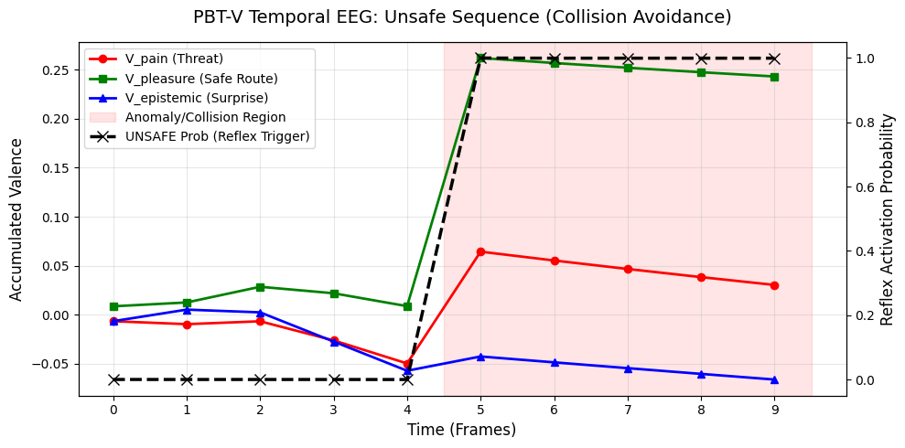

==========================================================================================
📊 CELL 6: Comprehensive Evaluation (PBT-V)
==========================================================================================
[Process] Evaluating Safe Sequence...
[Process] Evaluating Unsafe Sequence...

[Result] Classification Report:
precision recall f1-score support

SAFE (0) 1.0000 1.0000 1.0000 15
UNSAFE/ANOMALY (1) 1.0000 1.0000 1.0000 5

accuracy 1.0000 20
macro avg 1.0000 1.0000 1.0000 20
weighted avg 1.0000 1.0000 1.0000 20

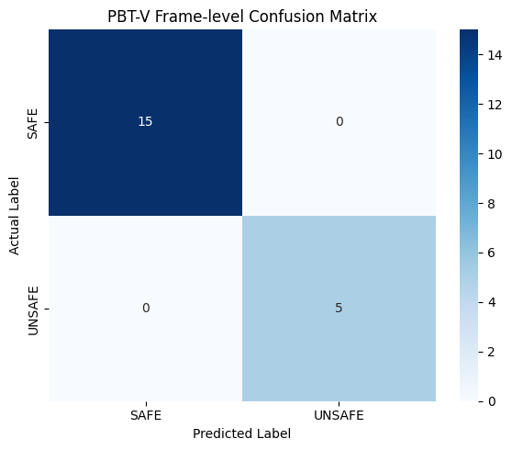

==========================================================================================
🌪️ CELL 7: Visual Noise Ablation Test
==========================================================================================
[Process] Generating Noisy Sequences (Noise Factor: 20%)...
[Process] Extracting features from Noisy Sequences via DINOv2...
[Process] Evaluating Noisy Sequences with PBT-V...

[Result] Classification Report (Noisy Data):
precision recall f1-score support

SAFE (0) 1.0000 1.0000 1.0000 15
UNSAFE/ANOMALY (1) 1.0000 1.0000 1.0000 5

accuracy 1.0000 20
macro avg 1.0000 1.0000 1.0000 20
weighted avg 1.0000 1.0000 1.0000 20

[Analysis] Clean Accuracy: 1.0000 | Noisy Accuracy: 1.0000
[Analysis] Robustness Drop: 0.00%

==========================================================================================
🕵️ CELL 8: Safe Anomaly / Over-refusal Test (Tricky-Safe)
==========================================================================================
[Process] Generating Tricky-Safe Sequence (Lighting Change)...
[Process] Evaluating Tricky-Safe Sequence with PBT-V...

[Result] Frame-by-Frame Predictions:
Frame 0 [Normal ] -> ✅ GO (Correct)
Frame 1 [Normal ] -> ✅ GO (Correct)
Frame 2 [Normal ] -> ✅ GO (Correct)
Frame 3 [Normal ] -> ✅ GO (Correct)
Frame 4 [Normal ] -> ✅ GO (Correct)
Frame 5 [Lighting Changed] -> ✅ GO (Correct)
Frame 6 [Normal ] -> ✅ GO (Correct)
Frame 7 [Normal ] -> ✅ GO (Correct)
Frame 8 [Normal ] -> ✅ GO (Correct)
Frame 9 [Normal ] -> ✅ GO (Correct)

[Analysis] Over-refusal Rate (False Positives): 0/10 frames
🌟 ยอดเยี่ยม! โมเดลแยกแยะได้ว่านี่คือแสงเปลี่ยน ไม่ใช่สิ่งกีดขวาง

==========================================================================================
⏱️ CELL 9: Temporal Reflex Scanner (Tricky-Safe EEG)
==========================================================================================
[Process] Running real-time inference on Tricky-Safe Sequence...
[System] Scan complete. Generating EEG visualization...
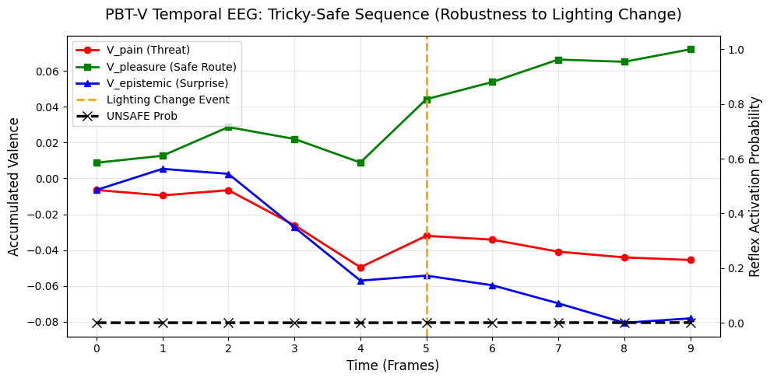

==========================================================================================
🌍 CELL 11: PBT-V Real-world Video Processing & EEG Scanner
==========================================================================================
[Process] Reading video file: 15562-264716034_medium.mp4
[Process] Successfully extracted 150 frames.
[Process] Extracting features via DINOv2...
[Process] Running PBT-V Temporal Reflex Scanner...
